addendum_revised (nhs111) Frequently Asked Questions

- How can our trust make use of the ESR Recruitment Module, as we do not currently use this functionality in ESR?

The Recruitment module is available to all Employing Authorities as part of the whole ESR solution, and can be utilised at any time. The local ESR Administrator is able to allocate the Recruitment and Applicant Enrolment Administration URP and Medical Staffing Officer Notification Role to the appropriate users and no additional setup is required to begin using the module, though some local training may be required.

- Do I have to ask the NHS ESR Systems Integration Team to switch the functionality on?

In order to utilise the Streamlined Doctors In Training Interface process, the ESR NHS Systems Integration Team requires a Service Request to be raised on the ESR Helpdesk. This will prompt the team to transition your organisation to the Streamlined interface process. Please raise a Service Request under the following offering: Request a Service – Junior Doctors Interfaces.

- How will the interface affect Lead Employer trusts, where the training posts are physically based at a different NHS Organisation?

It is possible to record whether you have a host or lead arrangement for a training post within your ESR VPD. This information enables HEE Local Offices/Deanery to share information with the lead and host employers.

- What happens for a Doctor in training if their post sits within a University or Hospice (or other NHS site)? Will these appear in ESR?

Users will now need to enter the Workplace Organisation Code (‘Workplace Org’) on the position DFF for those positions that are paid by their Employing Authority but where the work is actually undertaken on a location managed by another Employing Authority. This additional data item enables users to comply with the following annual Medical & Dental Workforce Census requirement:

Please ensure all re-charge doctors who are directly paid by your organisation are included. In the case of Lead Employer arrangements it is necessary for the Lead Employer to create an Employee Record and the local organisation/ host organisation may wish to create an honorary (non paid) record in ESR.

- What happens if I received late notification of a new starter from the HEE Local Office/Deanery i.e. the day before they are due to commence work?

You will need to use ESR’s Direct Hire Functionality as it would be too late for the applicant record to be transferred automatically via the Streamlined Doctors in Training interface. It is important to note that the applicant record has to exist in ESR 2 days before the projected start date. Applicants in ESR cannot be hired on the same day as they are received (on the day their applicant assignment is created), as an overnight process has to be run before this is possible. To support this HEE have applied validation in the Trainee Information System (TIS) to only export applications up until 2 days before their projected hire date.

- What happens to the Deanery Post Number once the applicant leaves their post? Is it recycled?

The HEE Local Offices/Deanery across England and Wales employ the principle that the Deanery Post Number is applied to the post and not the person. Therefore, when a person leaves a post, the Deanery Post Number will continue to apply to that post but is no longer associated with that particular individual. The DPN reference is therefore re-used when the next doctor is assigned to that position.

- How will ESR deal with the issue of Trainees (Doctors In Training) rotating within one trust, maybe working in three different departments/wards within a trust over a year and how the costing of this is to be handled to ensure that the correct information is transferred to the general ledger?

The Streamlined Doctors In Training Interface process supports internal rotations process. If a trainee is staying with the same employer, but moving to a different post, the new functionality should be utilised. The Streamlined Doctors In Training Interface process will create an application for an existing employee. The ESR user may then hire the trainee into the new post on the projected hire date. Further information about this process can be found in our e learning module: Junior Doctor (Doctors In Training) Interface – Hiring an Existing Employee.
.

- I understand that it is proposed that the Deanery Post Number must be linked to a position on ESR. Is this correct? If so, how can I do this?

In order for the interface to work correctly you must apply the correct Deanery Post Number (DPN) to each training position within ESR. Please note that there should be a one is to one mapping between the position number and the DPN. The same DPN should not be assigned to multiple position numbers. These are duplicate positions and ESR will produce a weekly notification where duplicate positions exist in a VPD prompting MSOs to tidy these up.

- Does the interface support job shares?
Yes the interface will support job shares. In this case the position will need to be set up in ESR as a shared position. The example is shown below. The position will be associated with a single DPN. In HEE , the post(DPN) could be allocated to multiple individuals who are working on a less than whole time basis. Hence more than a single applicant record could be received for a single ESR position number and a single DPN.
(Note: A post set up as ‘single incumbent’ will not allow two people to occupy the same post). This approach should be employed to accommodate Flexible Trainees. However, it is advised that the Trust are careful when they set up these records, to ensure the correct number of hours and remuneration are applied to the Employee assignment.

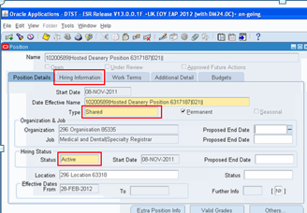
- What action should our organisation take if a Deanery Training Post is removed?

Using the Local Workstructures Admin URP, there are two options that your ESR Workstructures Lead may pursue. They may either:

- Deactivate the post by moving to the appropriate date (using the date tracking tool) and add an End Date to the position – The user should ensure that there is no one actively employed in the post prior to end-dating the post. The benefit of this approach is that you will retain the history that the position was a Deanery Training Post and no-one can be inadvertently allocated to it.
Or
- Retain the position as an active post and simply remove the reference to the Deanery Post Number, Managing Deanery Body field and Host/Lead Employer Flag. The advantage to this approach is that the post may still be occupied by other non-training employees.

Both options will result in the post being removed from the Streamlined Doctors In Training Interface process. Consequently, it will not be possible to transfer information (via the Doctors In Training interfaces) into or out of ESR for this position or any trainee who may be due to occupy this post.

- What should I do when a trainee goes on maternity, parental or adoption leave?

The trainee’s assignment status in ESR must be updated to ‘Maternity & Adoption’. This status will be picked up by the bi-directional interface ( see FAQ below) as and when this is implemented. This would notify the HEE Local Office/Deanery that the person has gone on leave. This enables a replacement to be recruited against the original DPN using the recruitment interface.
In the absence of the bi-directional interface, HEE and the trust will need to employ a mechanism outside the interface to communicate information about absences.

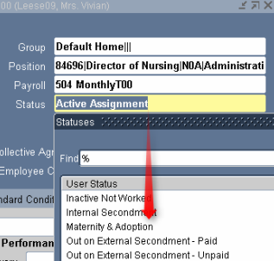

- What is the bi-directional interface? What does this mean for me?
The TIS ESR interface currently operates in a single direction. ESR receives applicant information from TIS and does not feedback information about the applicant to TIS (HEE). In the single directional interface the only data that is being shared by ESR with TIS is data about the position and not information about the individual occupying that position.
The bi-directional interface is under development with TIS and is planned for deployment by January 2020. This will allow the data about the individual to be synchronised between TIS and ESR. This means that ESR will exchange a wider set of information with TIS (HEE). This includes personal information, address details, professional registration details and absence details among others.

- Should we create a new position for Locum against Service (LAS) positions?

Yes; as LAS positions are not recognised training posts, organisations are advised to create and recruit to a new position for this scenario. Many of the LAS position details may be copied from the original training position but the LAS position must be given an Occupation Code and a Subjective Code which identifies it as a Locum post and it must not be given a Deanery Post Number (DPN).

- Should we create a new position for Locum against Training (LAT) positions?

No. LAT posts are recognised training positions and appointments are made by the HEE Local OFFICE/Deanery. The position must be given a Deanery Post Number (DPN) in order for the interface system to operate. LAT applications will be created via the Streamlined Doctors In Training interface as per the usual process for all recruits to recognised Medical & Dental training posts. Although it is not necessary to create a new position, you should ensure that the Locum version of the appropriate Occupation Code and Subjective Code is applied to the position for the period in which it is filled by a Locum as this information is used in local, regional and national analyses. Remember to update the Occupation Code and Subjective Code whenever a subsequent assignment is made to the position. If the position is no longer being used for a LAT appointment then the Occupation Code and Subjective Code should be changed back to the non-Locum version. This process will ensure that the HEE Local Office/Deanery System and also reporting at local, regional and national level will always receive and/or reflect the appropriate data.

- How will the interface work when a training post is managed by a HEE Local Office/Deanery with a different Deanery code to that within the training number? For example, an East of England post which is actually managed by the London Deanery.

In this event the Managing Deanery Body field in ESR should be populated. The Managing Deanery Body field is held in ESR on the same form where the Deanery Post Number is currently recorded. This will allow the interface to post the vacancy file to the correct HEE Local Office/Deanery System. When this field is completed, the interface will override the DPN and use the Managing Deanery information as the destination for the vacancy file. In the example above, the Deanery Post Number field should be completed with the East of England Post number, but the London Deanery value should be selected in the Managing Deanery field thus allowing London Deanery to receive the interface updates.
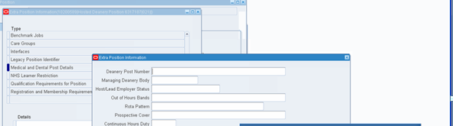
In example above the Managing deanery body will be LON

- Currently our Trainee posts have many different pay scales that could be applicable to one Deanery post. Is it possible to specify multiple pay scales (i.e. mark valid grade on the position set up)?

Yes, it is possible to set up a Position with a number of valid pay scales (Grades); with the appropriate one being selected for each Assignment in order for the person to receive the correct payment. This flexibility in ESR means that it is not necessary to create a separate version of the Position for each possible Grade that may be required. However, it is important to consult with your Finance Team, as this will have a direct impact on the use of subjective codes, ledger and budget reports.

- If a trainee occupies a post that does not contain a Deanery Post Number, but in the next rotation is allocated to a post that does have a DPN, will the existing employee record be matched with the new applicant record?

ESR will match existing records by comparing the all existing records in the VPD and the:

- Date of Birth matches
- Surname matches (case insensitive)
- First name matches (case insensitive)
- National Insurance Number (where provided)
- GMC Number

If a match is found, an applicant assignment will be created against the existing employee record.

- When should I expect my placement applications to be received in ESR before a rotation?

HEE England prepare the vast majority of placements within the Trainee Information System (TIS) to be released around 3 months / 90 days/12 weeks before a placement start date. This means you should receive a majority, if not all, of your placements to be received in ESR at this point in time. Please contact your local HEE Team if you do not believe this has happened.

• How will I know which placement applications I have received and which may have been rejected by ESR?

Once set up, ESR staff with the Medical Staffing Officer (MSO) role will receive ESR workflow notifications that detail which applicants have been successfully received (ready to hire) and also which have been rejected by the system, with the reason why included. The rejections may then need to be direct hired in ESR at the earliest opportunity.

- How will I know who to contact if any issues arise?

There is a support diagram within the ESR-NHS0111 The Streamlined ESR and Deanery System Interface Guide (Section 6. Essential Information and Quick Reference Trouble-shooting Guide) that can be used for reference.

Please see the link below for captivate sessions that will walkthrough key ESR and Doctors in Training activities: https://www.roadmapeducation.online/esrlearning/DIT%20Captivates.zip

- My organisation uses TRAC for the management of Doctors in Training pre-employment checks. Can I still use the interface between ESR and TIS?
There was a concern expressed by some organisations that using TIS ESR interface in conjunction with TRAC for pre-employment checks could cause duplicates. Duplicates will be caused if Approach B is used i.e.where instead of only the TIS-ESR interface creating applicant records for the DiTM the E-Rec interface also creates an applicant record for the DiT. See diagrams and process steps below. It is recommended that where Trusts are using TRAC and the TIS-ESR interface they utilise the interface in the manner in which it is designed to operate and which is highlighted in Approach A below.

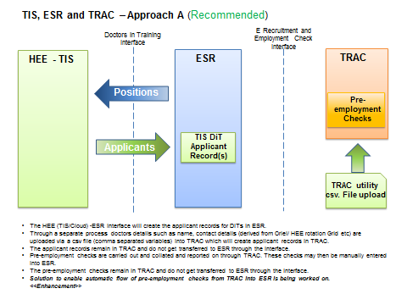
recommended approach

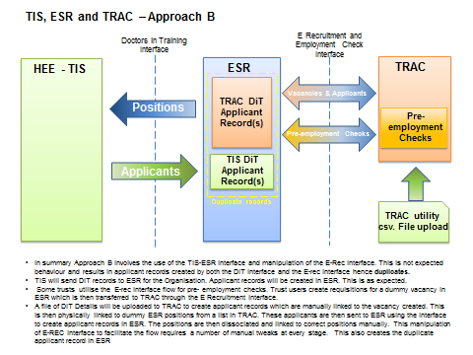
Creates duplicates. Not recommended

- Following from above what are the issues that a trust could face if they are moving from Approach B to Approach A?
Duplicate applicant records may exists historically. This will need to be tidied up. A report of duplicate applicant records can be made available on request from the Trust.
- Our MSOs receive notifications around DITs which some MSOs may not know how to progress.
- MSO could reassign the notification to an individual that is better placed to action the notification.

- What information is available about the different notifications that MSOs receive?
A NHS ESR Workflow notifications guide is available on request.Refer ESR NHS0060 Workflow Notifications Guide v20.0 pdf

- What reports are available for me to use to assist with placements?
Please see Detailed information pack (available in KBASE)

- What information is available about WTE
ESR currently receives information about the WTE for the next placement on the notifications file from HEE. This is displayed on the Medical Rotation spreadsheet against the next placement.

- What do I do when I am notified that an applicant hasn’t loaded successfully in ESR?
It is not currently possible for HEE to manually resend applicants that have failed to load successfully into ESR via TIS, on the first attempt. As a consequence this applicant will have to be directly hired into ESR and details of applicants manually entered into ESR. Where you see a repeated occurrence of issues, which cause applicants to fail to process successfully within ESR, please notify your HEE local office so that steps can be taken to improve the data quality and minimize unsuccessful loads.

- What if the MSO role in ESR is receiving notifications for non-medics?
A number of different user roles can be set up in ESR. This is to serve different functions. One of those roles is the medical Staffing officer role. In order to receive notifications generated by the TIS-ESR interface, appropriate individuals need to be associated to the Medical Staffing Officer role. If the MSO role is receiving notifications that are not appropriate, please consult the ESR User Manual and the ESR Workflow Notification Guide (ESR NHS0060 Workflow Notifications Guide v20.0 pdf) and set up roles accordingly. The ability to set users into roles lies with individuals that are set up with System administrator access in ESR in your organisation

