# Multi-factor Authenticator (MFA) Frequently Asked Questions (FAQs)



Frequently Asked Questions

**What is MFA, and why is it important?**

MFA is a security measure that requires multiple verification methods to ensure that the person accessing an account is indeed the authorised user. It is crucial because it adds an extra layer of security, making it more difficult for unauthorised users to access sensitive information.

**How will it work?**

1. Enter your username and password on the login page as normal.

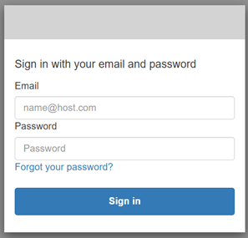

1. You will be prompted to enter a code sent to your registered email address.

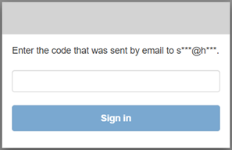

1. Retrieve the code from your email and enter it into the designated field on the login page.
2. If the code matches the one generated by the system, you will be able to log in.
3. If you enter the code incorrectly, you will be prompted to try again. If the code expires, you will be prompted to login again and a new code will be sent.

**Why Are We Implementing Multi-Factor Authentication?**

MFA is a proven method for preventing unauthorised access and data breaches. It's a critical step in protecting your account and the organisation's valuable data.

Benefits of Multi-Factor Authentication:

1. Enhanced our Product’s Security: MFA significantly reduces the risk of a successful cyber-attack by requiring multiple forms of verification.
2. Protection Against Phishing: Even if a password is compromised, an attacker cannot gain access without the second factor.
3. Regulatory Compliance: MFA helps in meeting regulatory requirements for data protection and security in the NHS. What types of authentication methods will be used?

**What should I do if I encounter issues with MFA?**

Email messages may arrive in your spam or junk folder. Please check these folders if your email authentication message doesn't arrive. Networking issues may delay email messages. If the email authentication message arrives after the code has expired, you must request another email authentication message.

If you experience any issues with MFA, please immediately. For NHSE staff visit TIS Support, for Trust and other NHS, please visit Support for Trust staff.

**Will MFA be mandatory for all users?**

Yes, MFA will be mandatory for all users to ensure the highest level of security for our platform.

**What if I lose access to my second factor of authentication?**

If you lose access to your email or authenticator app, please contact the TIS support team. We will guide you through the process of regaining access to your account after verifying your identity.

**How can I prepare for the MFA rollout?**

To prepare for MFA, ensure that the correct email address is listed in your TIS account settings.

**Remembering your password**

* Browsers are great for improving security for anyone tempted to re-use passwords.
* Sometimes, you may need access to your password in somewhere other than the usual place you enter it.
* In a short few steps you can see the password you have for any website, including TIS!

**Instructions**

 We support Chrome, the steps for other browsers are similar.

1. Open your browser and go to the password manager, as shown in this image:

2. Find the TIS saved password:

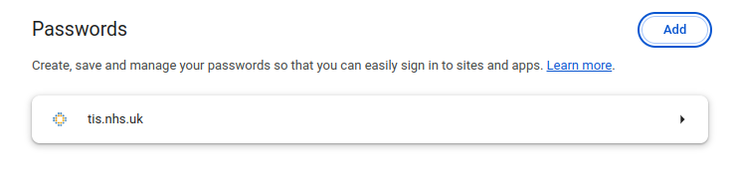3. Use the “eye” to see your current password or the “copy” icon to… copy the password ready to paste where you need it!

